Ramping up the Understanding of
Acceleration and Velocity Pre-Test

Directions:

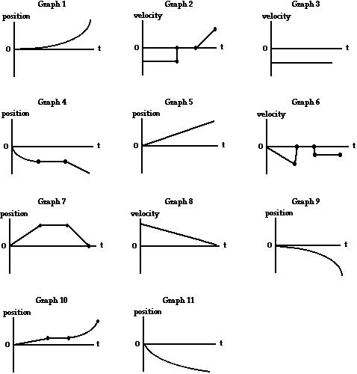

Directions: For each of the statements below, write the graph that corresponds to the description.

- _______The object moves with a positive velocity and a positive acceleration.

- _______The object moves with a constant negative velocity. Then, the object remains at rest for several seconds. Finally, the object moves with positive acceleration.

- _______The object moves with a constant negative velocity.

- _______The object moves with a negative velocity. Then, the object remains at rest for several seconds. Finally, the object moves with a low, constant speed.

- _______The object moves with constant speed in the positive direction.

- _______The object slowly accelerates from rest. Then, the object remains at rest for several seconds. Finally, the object moves with a constant negative velocity.

- _______The object moves at constant speed. Then, the object remains at rest for several seconds. Finally, the object moves with a constant negative velocity.

- _______The object moves in the positive direction with a negative acceleration.

- _______The object moves in the negative direction with a negative acceleration.

- _______The object moves with a low speed for a short time interval. Then the object remains at rest for several seconds. Finally, the object rapidly accelerates with a positive acceleration.

- _______The object moves with a negative velocity and a positive acceleration.

